Location
PATIENT INSTRUCTIONS
CLINICAL LABS COVID-19 DRIVE-THRU TESTING
2-4 SPEED ST, LIVERPOOL NSW 2170 (Updated 13.5.20)
2-4 Speed St, Liverpool 2170

Opening Hours
M-F: 9am – 5pm

Patient Check List prior to visit
Pathology request form* from doctor | Medicare card
Checked opening hours on clinicallabs.com.au/location | Made a booking (optional)

Steps on Arrival
- Drive to COVID-19 drive-thru collection centre
  - Drive into the council carpark, head straight down and follow the driveway on the left
  - Head down the driveway and turn left again
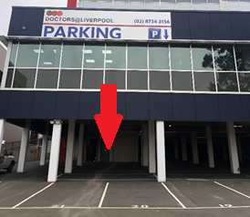
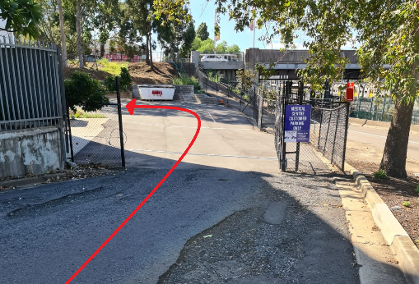
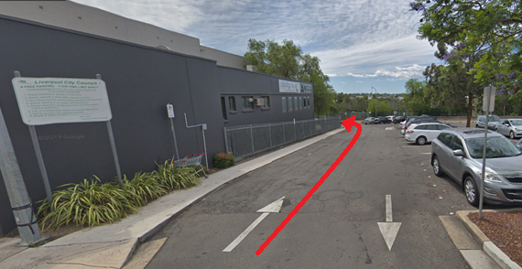
  - Follow arrows to designated parking spots

- Turn vehicle engine off once parked
- Passengers must remain in vehicle with request form and Medicare card ready.
- Clinical Labs staff member will attend to the patient in the car and collect the swabs.
- Results will be sent to your referring doctor (Turn-around-times may vary with demand).
*Doctors can request the pathology test via:
Print and arrange for the patient to pick up the request form the medical centre. | OR | Fax signed request form to the collection centre 02 8867 1951. | OR | Email a digital copy of the signed request form to the patient.  Patient prints the email and request form prior to visit.
More information:
Collection centres - clinicallabs.com.au/location
COVID-19 information and collection centres visit clinicallabs.com.au/coronavirus

